8

Code Metrics / Analyzers

Check Your Source Code’s Complexity
Adding a cyclomatic complexity check to your development process can quickly point you to potentially troublesome areas of your code base. SourceMonitor, written by James Wanner of Campwood Software, is a simple tool which gathers cyclomatic complexity statistics and other metrics for many languages including C#, C++, C, Java, Delphi, Visual Basic (classic only), and even HTML. SourceMonitor also reports on 11 other useful metrics including total lines in code files, number of classes, average of methods per class, and statements per method. See SourceMonitor’s documentation for a full listing and explanation of metrics covered by the tool.
Tool: SourceMonitor | Version: 2.0.4.7
Homepage: http://www.campwoodsw.com/sm20.html
Power Tools Page:
Summary: Lightweight tool for gathering metrics on several languages. Customizable and easy to use. Can be used by automated build and CI processes.
License Type: Freeware.
Resources: Help file only. No online resources.
Related Tools: Vil, CR_Plugin.
One of SourceMonitor’s greatest features is its tracking of code changes through checkpoints. You create a project in SourceMonitor containing all your source code, then run an analysis pass on that project to create statistics. A baseline of metrics is created and you’re able to measure each subsequent analysis pass against that baseline to monitor the overall complexity of your project. This will help you better understand your complexity vs. feature curve as you add functionality into your software.

Requirements
SourceMonitor runs on 32-bit Windows platforms: Windows 95/98, Windows NT, Windows 2000, and Windows XP. It will happily work with source files written on other platforms.

Setup
SourceMonitor’s download is a simple executable Which you download from its homepage.

Creating a Project
Start SourceMonitor for the first time and you’ll see SourceMonitor’s empty project screen as shown in Figure 8-1.
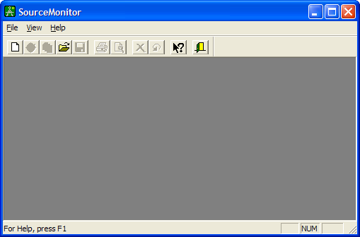
Figure 8-1. SourceMonitor’s opening screen
All metrics in SourceMonitor are tracked via project files. Create a new project by clicking the New Project icon, or by selecting File → New. You’ll be prompted to select the type of source files you want to analyze, as shown in Figure 8-2.
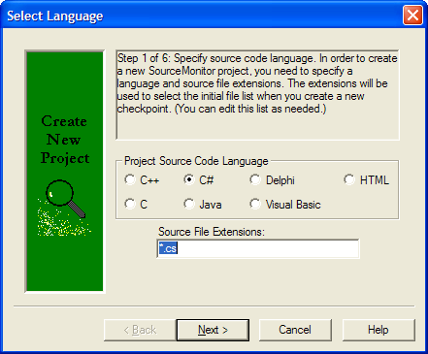
Figure 8-2. Selecting a language for the project
Setting up the project is a simple process. Options in the remaining setup dialogs allow you to select directory trees and specific files to include or exclude, and whether or not to ignore large header/footer comment blocks. (Such blocks often contain copyright information, contact data, CVS keywords, etc., which would skew metrics if included.). Additionally, you can configure an initial checkpoint for your project.

After you’ve completed the initial project configuration, SourceMonitor sets off on its analysis pass. The baseline checkpoint is saved and displayed in the main window. Additional analysis passes are saved as other checkpoints and are also displayed as shown in Figure 8-3.

Using the Metrics
SourceMonitor’s main window gives a quick overview of each checkpoint’s metrics. SourceMonitor provides detailed descriptions of each metric in the tool’s help file
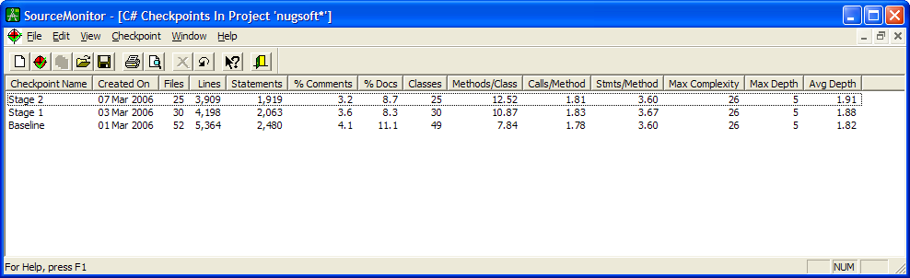
Figure 8-3. Project listing several checkpoints
Right-clicking on a checkpoint displays a context menu exposing options to change the project’s properties, examine files for that checkpoint, or manage checkpoints (create new, delete, rename). You can also modify a checkpoint’s creation date. More importantly, the context menu gives full access to SourceMonitor’s great metrics.
SourceMonitor provides complete statistics on individual checkpoints and also across the entire project. Individual metrics are displayed by selecting View → Display Checkpoint Metrics Summary from the menu, or by right-clicking on a checkpoint and selecting Display Checkpoint Metrics Summary.
The resulting summary shown in Figure 8-4 gives a wealth of information on that checkpoint, including a complete listing of all methods and their complexity. The Block Histogram and Kivat Graph give a quick bird’s eye view of the project’s complexity.
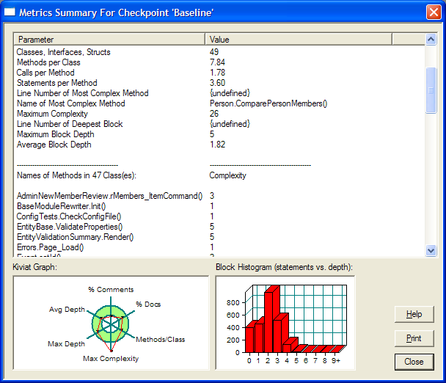
Figure 8-4. Metrics summary for a checkpoint
Kiviat graphs, also called “star charts” or “radar graphs” give a clear overview of several metrics at once. SourceMonitor provides a larger view of a Kiviat graph for any checkpoint by selecting View → Display Checkpoint Kiviat Graph, or via the same option in the checkpoint’s context menu. Threshold values for this graph can be set for each language type via File → Options as shown in Figure 8-5.
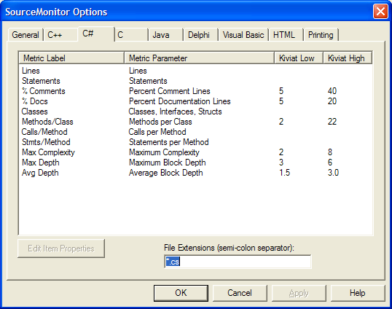
Figure 8-5. Setting language-specific metric options
Points outside the green donut in the Kiviat chart mark metrics which are outside the thresholds set in the options dialog. Figure 8-6 shows two troublesome metrics: a low percentage of comments, and high maximum complexity.
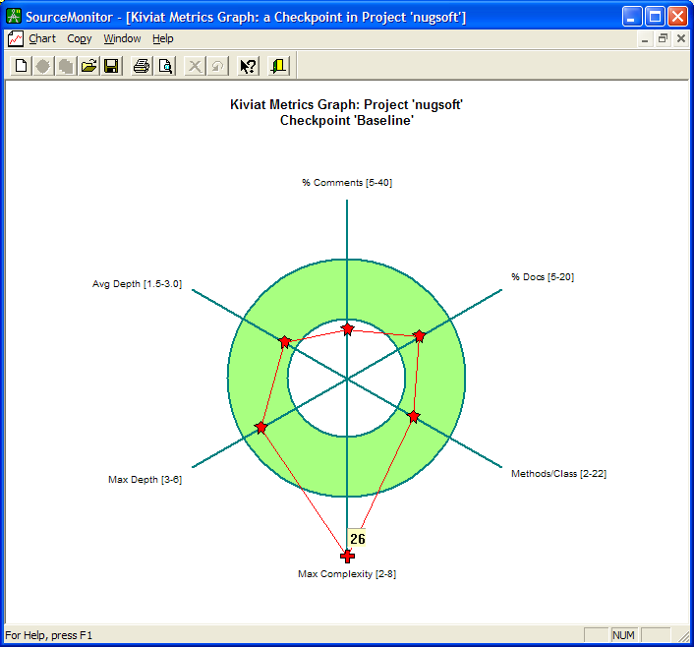
Figure 8-6. Kiviat graph showing maximum complexity out of range
It’s easy to chase down the offending code for metrics which are out of range. Simply select View Checkpoint Files from the View or context menu for any checkpoint. A new window is displayed showing all files in the project. Each column in the metrics grid can be sorted, quickly popping high values to the top of the display.
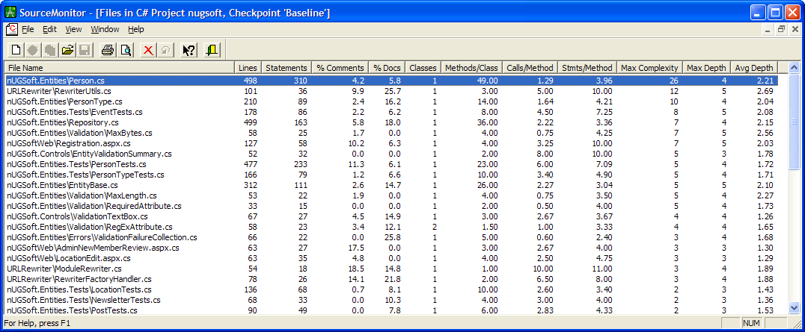
Figure 8-7. Project files sorted by maximum complexity
Right-clicking on any file will allow you to select View Source File which opens a new viewer window. Note the two buttons at the top: Deepest Block and Most Complex Method. Clicking either will take you directly to the line and highlight it.
For example, Figure 8-8 shows the offending portion of code behind the cyclomatic complexity value of 26. Note this method handles comparing two business entities. The method, straight out of Bill Wagner’s Effective C#, runs through most of the entities’ public properties comparing the two. This method really can’t be refactored, but the high complexity metric indicates you’ll need to work hard on getting thorough test cases to exercise all paths through this section.
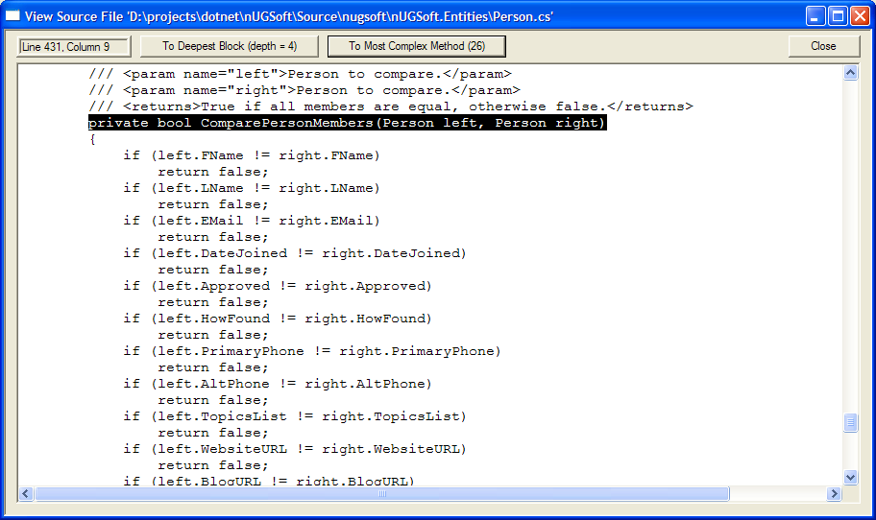
Figure 8-8. SourceMonitor’s viewer displaying the most complex method
Metrics on individual checkpoints are impressive and vastly useful; however, SourceMonitor’s ability to chart project metric progress over time is just as powerful. Select View → Chart Project Metrics from the main or context menus and you’ll be able to page through charts displaying all 12 metrics gathered by SourceMonitor. PageUp and PageDown keys provide quick navigation through the graphs, and you’re also able to customize the plot line color or export the chart to a .BMP file. Figure 8-9 shows the Methods per Class metric across three checkpoints.
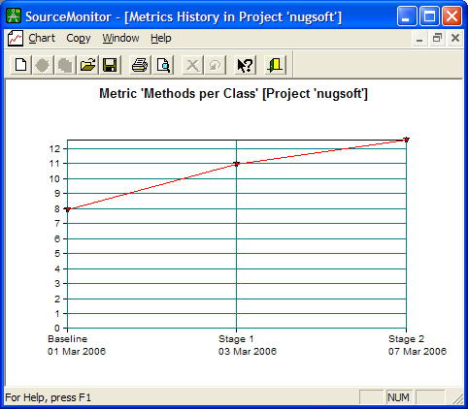
Figure 8-9. Metrics across a project

Running Via The Command Line
SourceMonitor can be run via the command line, making it easy to wrap it into any automated builds you might be using. An XML configuration file stores commands (sample included with the installation), making batch operations easy. Wanner includes a comprehensive sample command file with the installation, plus there’s extensive documentation in the help file.
This example shows a command file which uses an existing SourceMonitor project, writes data to an XML report (it’s saved in the project, too) and leaves the checkpoint in the project file.
<?xml version="1.0" encoding="UTF-8" ?>
<sourcemonitor_commands>
<!-- write to log in install directory, or
C:\Documents and Settings\<name>\Application Data\Campwood Software
if the current user can't write to that directory -->
<write_log>true</write_log>
<command>
<!-- Use an established project file --> <project_file>D:\projects\dotnet\nUGSoft\Source\nugsoft\nugsoft.smp</project_file>
<!-- No checkpoint name specified; auto-generate one.
<checkpoint_name></checkpoint_name>
-->
<!-- export an XML report. CSV also available -->
<export>
<export_file>SM_Metrics.xml</export_file>
<export_type>2 (checkpoint details as XML)</export_type>
</export>

<!-- Don't delete the checkpoint, save info in project file
<delete_checkpoint/>
-->
</command>
</sourcemonitor_commands>
Run SourceMonitor from the command prompt like so:
"C:\Program Files\SourceMonitor\SourceMonitor.exe" /c sm_commands.xml
Other command options enable you to create new projects, specify and exclude entire directory contents, and export to different formats. See SourceMonitor’s help file for details on other options.

Integrate Into Visual Studio’s IDE
As with any external tool, SourceMonitor can also be invoked from within Visual Studio’s IDE. See Appendix [???] for details on adding tools to Visual Studio’s environment. Visual Studio Hacks, by James Avery, is another source on how to tweak Visual Studio’s environment.

Pros and Cons
Downsides exist to SourceMonitor. First off, it doesn’t support ASP.NET. Additionally, there’s no user community exchanging ideas on the tool. The largest hit is that it doesn’t support VB.NET in any form; however, the tool’s author has put VB.NET as his number one task for his next release.
These cons are far outweighed by the tool’s positives. (Unless you’re working in VB.NET…) First off, it’s fast. Wanner’s parsers get through 10,000 lines of code per second. Secondly, it’s exceedingly clear and simple to use. Navigation is common-sense and has many alternative methods to reach any particular piece of functionality. SourceMonitor is also very configurable in its metrics displays, enabling users to customize displays for their particular environment. Lastly, its command-line interface allows SourceMonitor to be wrapped into any automated build or continuous integration environment.
Version 2.1 is in beta test as of this writing. Its enhancements include several UI improvements, but most importantly additional export options. Metrics reports can now be saved with raw data instead of ratios, and summary data can be appended to each line for checkpoint metrics.

See Also
[Cr_plugin]
[Vil]

Summary

Support for SourceMonitor is solely via bug reports and feature requests sent to the author’s e-mail address: jim@campwoodsw.com. Unfortunately, there are no online communities supporting the tool.
SourceMonitor gives users a powerful, fast, configurable tool to track metrics over a project’s entire lifespan. It’s easily wrapped into any continuous integration or automated build processes you may have in place. Its speed and ease of use also make it a great tool for quick looks at portions of the code base you may be working on at the moment.

